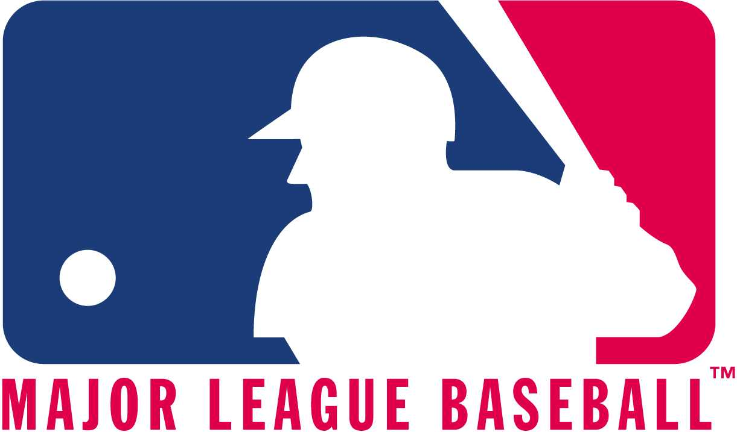

FOR IMMEDIATE RELEASE 17 May, 2007

MLB ENVOY COACH TO HOLD CLINICS AT U.S. ARMY BASES IN GERMANY AND ITALY

U.S. Army Child and Youth Services in partnership with the Boys and Girls Club of America and Major League Baseball is sending professional baseball coach John Noce to U.S. Army bases for a series of baseball clinics in Germany and Italy.

“Major League Baseball is very excited to be a part of this initiative,” says Manager of Game Development for Major League Baseball International Jason Holowaty. “Through these clinics, we are hoping to prepare the kids to play at higher levels and show them what the top high school and college programs are looking for.”

Noce will teach children ages 6-18, adults, coaches, and Child and Youth Services personnel how to succeed in upper level baseball by demonstrating various skills and techniques including: batting, sliding, throwing, fielding, and pitching. For the adults and coaches, the demonstrations will also include rules of the game, drills, and lessons on how to motivate kids and build fundamental skills. In addition to the demonstrations, Noce will discuss education, scholarships, sportsmanship, dedication, attitude, and what top college programs are seeking in recruits.

John Noce played professional baseball for the Stockton Ports and Ventura Oilers of the California State League from 1952-1953. After his playing days, Noce turned his attention to coaching and managed teams in Canada and Italy from 1973-1980. He served as an assistant coach for the Italian National Team from 1977-1996 and helped the team compete in six European Championships and three Olympic games. In the United States, Noce coached the College of San Matteo for 31 years winning 772 games and 13 conference championships. He has worked as MLB Envoy coach in Austria, Romania, and Holland. Noce was inducted into the American Coaches Association Hall of Fame in 1993.

The Major League Baseball Envoy Coach program has been MLB’s flagship international project since 1993. Since it’s the program’s inception, MLB has sent hundreds of professional coaches to over 75 different countries around the world to work on baseball development projects.

For more information, contact ……….
###

2007 Major League Baseball Clinics:

7-8 June: Darmstadt, Germany
11-12 June: Landstuhl, Germany
14-15 June: Baumholder, Germany
18-19 June: Schweinfurt, Germany
21-22 June: Stuttgart, Germany
2-3 July: Vicenza, Italy

